Name: ________________________________________ Arr: _________

Chapter 16 Written Problems

**Use this sheet to record your answers to the following Chapter 16 Challenge Problems.**

1. The code below is meant to turn on a microcontroller’s onboard LED but it contains **one mistake**. Do **not** run this code with your microcontroller – instead, **identify** and then **correct** the mistake.

void setup(){

pinMode(13, INPUT);

}

void loop(){

digitalWrite(13, HIGH);

}

1. The code below is meant to turn on a microcontroller’s onboard LED but it contains **one mistake**. Do **not** run this code with your microcontroller – instead, **identify** and then **correct** the mistake.

void setup(){

pinMode(13, OUTPUT);

}

void loop(){

digitalWrite(13, LOW);

}

1. The code below is meant to turn on a microcontroller’s onboard LED but it contains **one mistake**. Do **not** run this code with your microcontroller – instead, **identify** and then **correct** the mistake.

void setup(){

pinMode(13, PUTOUT);

}

void loop(){

digitalWrite(13, HIGH);

}

1. The code below is meant to turn on a microcontroller’s onboard LED but it contains **one mistake**. Do **not** run this code with your microcontroller – instead, **identify** and then **correct** the mistake.

void setup(){

pinMode(13, OUTPUT);

}

void loop(){

digitalWrite(12, 1);

}

**Figure 16.53.** A train of pulses. What is the pulse width, period of the wave, and frequency of the wave? What is the time between a rising edge and a falling edge? What is the time between subsequent leading edges?

150ms

750ms

900ms

1. Fill in the blanks of the following code with values that could be used to create the square wave shown in Figure 16.53 with the Teensy’s signal pin 8. Assume that the signal pin has been properly placed in OUTPUT mode.

digitalWrite(8, ______________________ );

delay( ______________________ );

digitalWrite(8, ______________________ );

delay( ______________________ );

1. In Figures **A**, **B**, and **C** below, certain specific PRT3 motherboard pins are highlighted. Identify which figures highlight the **power**, **ground**, and **signal** pins of the motherboard.

**Figure A.**

**Figure B.**

**Figure C.**

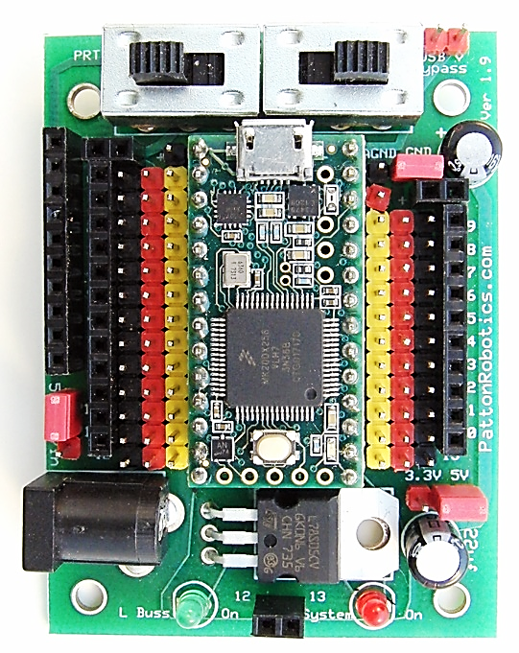

Turn in this sheet to be graded.